OLD EMANUEL ASSOCIATION: MARCH 2024 NEWSLETTER
Welcome to the 1st March version of the OEA Newsletter…this time entitled:-
"Spring has Sprung, The Grass is Riz, I wonder Where dem Birdies is?"

Don't you just love the 1st of March? All those long days behind you even if there are some cold (and wet) ones still due...but, here we go, at least eight months of getting on out there and enjoying foreign and domestic climes, if we remain able, as often as possible. If you're doing anything you feel fellow members would be interested in, let me know if you would care to share and I will report accordingly.

Some of the more hardy chaps got out there in February (and some of the more sensible stayed at home.) Here are the comments for OEA March 1st Newsletter:-

First…a big welcome to three new members:- Julian Carr ( Nelson 73-79): Bernard Higgins (Drake 73-78) and Martyn Gallop ( Marlborough 65-72). Welcome All. Mr. Gallop increases the number of ex Marlborough House Captains amongst us!!

1. OERFC Past and Vice-Presidents' Day, 17 February 2024

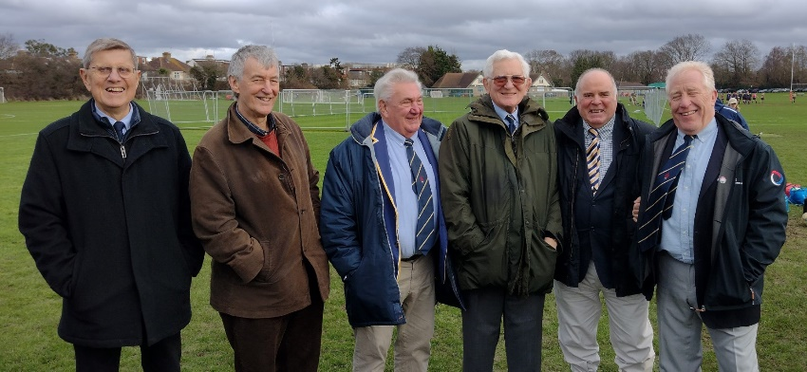

Messrs Price, Ventham, Sturgeon, Williams, Bryce and Lippiatt- as if it was 1975

A great day was had by 24 past players/vice presidents at the club's brand spanking new ground at Taunton Avenue, Raynes Park, organised diligently by Club President, Brian Cassidy. What an amazing edifice and playing surface they have produced...a simply outstanding achievement! I encourage all reading this to arrange a visit and familiarise yourself with the mountains that have been moved. Opening hours of The Pavilion: SW20 are Weds, Thurs & Fri 6.30 to 11pm: Sats 12 to 11pm: Suns 12 to close
Between them the past players attending had made over 4,000 1st XV appearances and scored in excess of 1,000 1st XV tries, let alone all the points that Price G. stuck over the posts. Consequently, there was much inter-spectator memories.

Messrs. Luck, Barlow (on slant), Robertson and Dart shown below:-
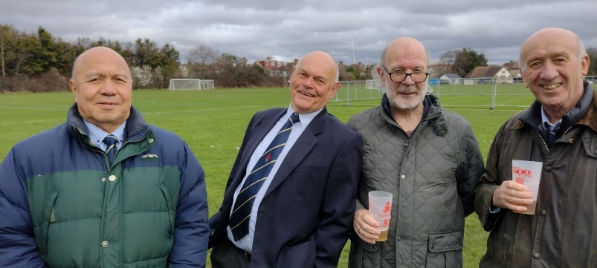

2. A "Brief Encounter* Event at The Three Guineas,* Reading Station on Wednesday 21st February 2024 organised by our Secretary Tim Broomfield and our Social Secretary, Andy Robertson.

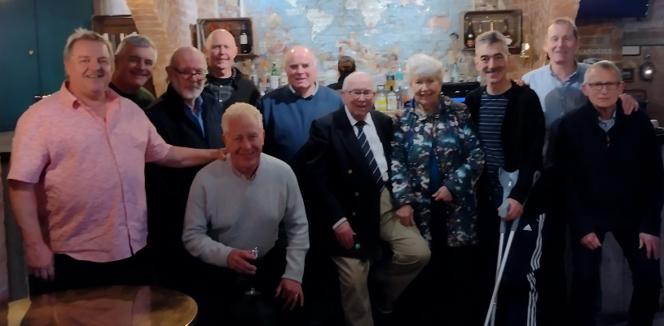

Messrs Agutter, Cassidy, Robertson, Bowen, Lippiatt, Bryce, Summers, Berenice, Maidment, Broomfield and Gallop (with apologies to those who left earlier)

Tim Broomfield reports:-

Last Orders
Roughly twelve of us met for a casual lunch at “The Three Guineas” located next to Reading Station. Formerly the ticket office for Brunel’s Great Western Railway, it is now an impressive Fuller’s hostelry, which accommodated us in their quirky “Firefly Cellar Bar”.
Our small, but perfectly formed group, connected immediately. Was this due to the camaraderie accumulated over many years and the common bond formed at School? Our fading memories were boosted by some images from the Archives (see Digital archive - Emanuel), e.g. which OE (1968-75) played in the punk band “UK Subs”? Also a photo of a reel-to-reel tape recorder entitled “1975-Experimenting with modern technology”. This was soon to be surpassed by TBL’s truly modern www!
As our drinks worked their magic, conversation became more animated, but never exaggerated. By now Gordon (long hot) Summers (1946-52) was going to enter the London Marathon and Brian (Cass) Cassidy was vying with Frances Emeruwa (not present – fortunately) as the best backrower to have ever attended Emanuel.
Before our talk became ridiculous the departures board prompted our last round. It proved expensive for two of our gang who missed their scheduled train and suffered a peak fare surcharge of £60 each. A small price for such special moments. Watch this space for future visits to Railway Venues around the UK. Suggestions welcome.
* Why is it called "The Three Guineas"? ...well in 1904 the General Manager of the then GWR ran a competition to name the record-breaking locomotive that was to travel the 245 miles non-stop trip from Paddington to Plymouth and then onto Penzance. From over 1,250 entries, two entries were combined and The Cornish Riviera Express was born. The prize...Three Golden Guineas.

3. UPCOMING EVENTS
A. MONDAY 11TH MARCH…THE OEA Luncheon Club at the Doggett’s Coat and Badge, Blackfriars organised by the inimitable Stuart Cameron-Waller. Celebrate Stuart’s 50th event he has organised since he put his hand up!! (OK it might not be quite 50 but very close and, anyway, who’s counting?) …see the CONNECTIONS page on the website www.theoea.co.uk for joining instructions. We’d love to see you…go on, don’t be shy!!

B. OERFC PRESIDENT’S DAY on SATURDAY 16TH MARCH, Taunton Avenue, Raynes Park
It’s open day at the club. This is OEA Members’ chance to wee the new clubhouse in all its glory starting around midday. No need to book/pay beforehand but please let Cass know if you are coming. Casual attire. rugbycass@gmail.com

C. OERFC CITY LUNCH on Friday 4th October 12pm-5pm at Smith & Wollensky, WC2
If you would like more details on this event, still some seven months away, please contact me on oeamember@gmail.com and I will forward you the details.

D, Details of the The OEA Annual Lecture (Planned for May), A possible Race Day in the Summer, The OERFC Festival Day (Planned for Sept/Oct) and The OEA Dinner at the School (Planned for November) will be issued as soon as they are available.

4. It’s great to report that OEA Member Johnnie Burn won a BAFTA in the recent awards for his Sound work on the film “The Zone of Interest”. When you view it, you can do so now with renewed interest!! See him on You Tube…an interview with Ashton Gluckman.

5. The School issued Number 40 of the e Version of The Rose and Portcullis last week containing stories on the new Science and Dining Building: The Careers and Higher Education Convention: The Goddard Lecture: Historical Walking Tours of Emanuel:
If you would like me to forward you a copy please contact me. (see details at end).

6. An OEA Member recently got in touch with me asking if I would be interested to receive a report on his visit abroad where he took time to give respect to departed OEs who had played a part in WW2. That’s for another time but it serves as a reminder to me to ask all of you reading this that if you would like to share relevant stories with your fellow members…then this is the conduit. Please get in touch. (I’m currently researching general information on all the individuals mentioned in Lady Anne Dacre’s will for example which might be of interest to at least one other person. It keeps me off the streets!) Please let me know if you have written any essays or books, built any buildings, traversed any seas or built any businesses…you get the drift….and if you’d like to share the story…I feel it may enhance the content of these monthly newsletters.

7. Don’t forget to visit the website for a comprehensive study of all things OEA and Emanuel School. If you are so inclined and learn to navigate the website accordingly you can lose yourself there for hours…and hours. www.theoea.co.uk

8. Finally, I'm sorry to have to report the deaths within the last month of Connor McDermott, Paul Richmond and Derek Saunders...RIP Dear OEs. Obituaries will be presented within school newsletters.

Andy Bryce, Marlborough 1963-70: oeamember@gmail.com: www.theoea.co.uk

